Creating Python Programs
Jeremy Matthews
Colorado State University Global
CSC500– Principles of Programming
Dr. Douglas Mujeye
Due Date: 02/15/26

Part 1: Addition and Subtraction
Psuedocode
BEGIN
PROMPT user for num1
PROMPT user for num2
sum = num1 + num2
difference = num1 - num2
DISPLAY sum
DISPLAY difference
END
Source Code
num1 = float(input("Enter the first number: "))
num2 = float(input("Enter the second number: "))

addition = num1 + num2
subtraction = num1 - num2

print("Addition:", num1, "+", num2, "=", addition)
print("Subtraction:", num1, "-", num2, "=", subtraction)

Part 2: Multiplication and Division
Pseudocode
BEGIN
PROMPT user for num1
PROMPT user for num2
product = num1 * num2
quotient = num1 / num2
DISPLAY product
DISPLAY quotient
END
Source Code
num1 = float(input("Enter the first number: "))
num2 = float(input("Enter the second number: "))

multiplication = num1 * num2
print("Multiplication:", num1, "*", num2, "=", multiplication)

if num2 != 0:
division = num1 / num2
print("Division:", num1, "/", num2, "=", division)
else:
print("Division: Cannot divide by zero!")

Screenshots
Application Executing Program
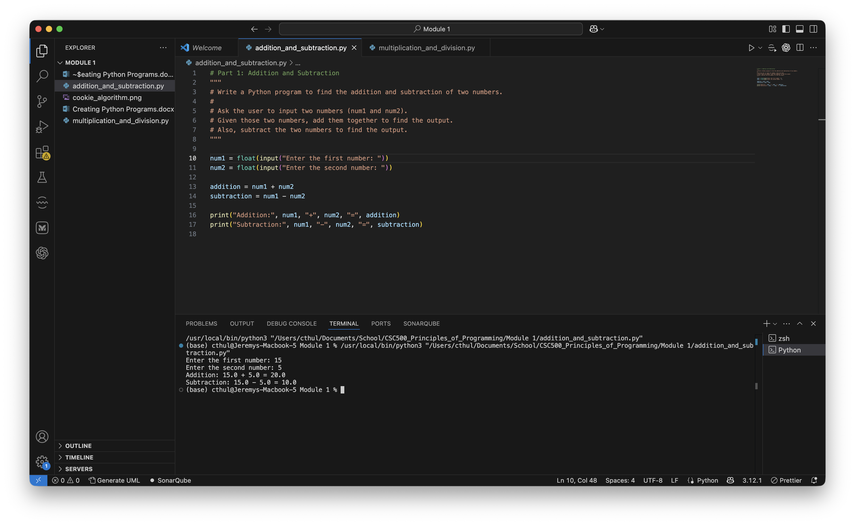
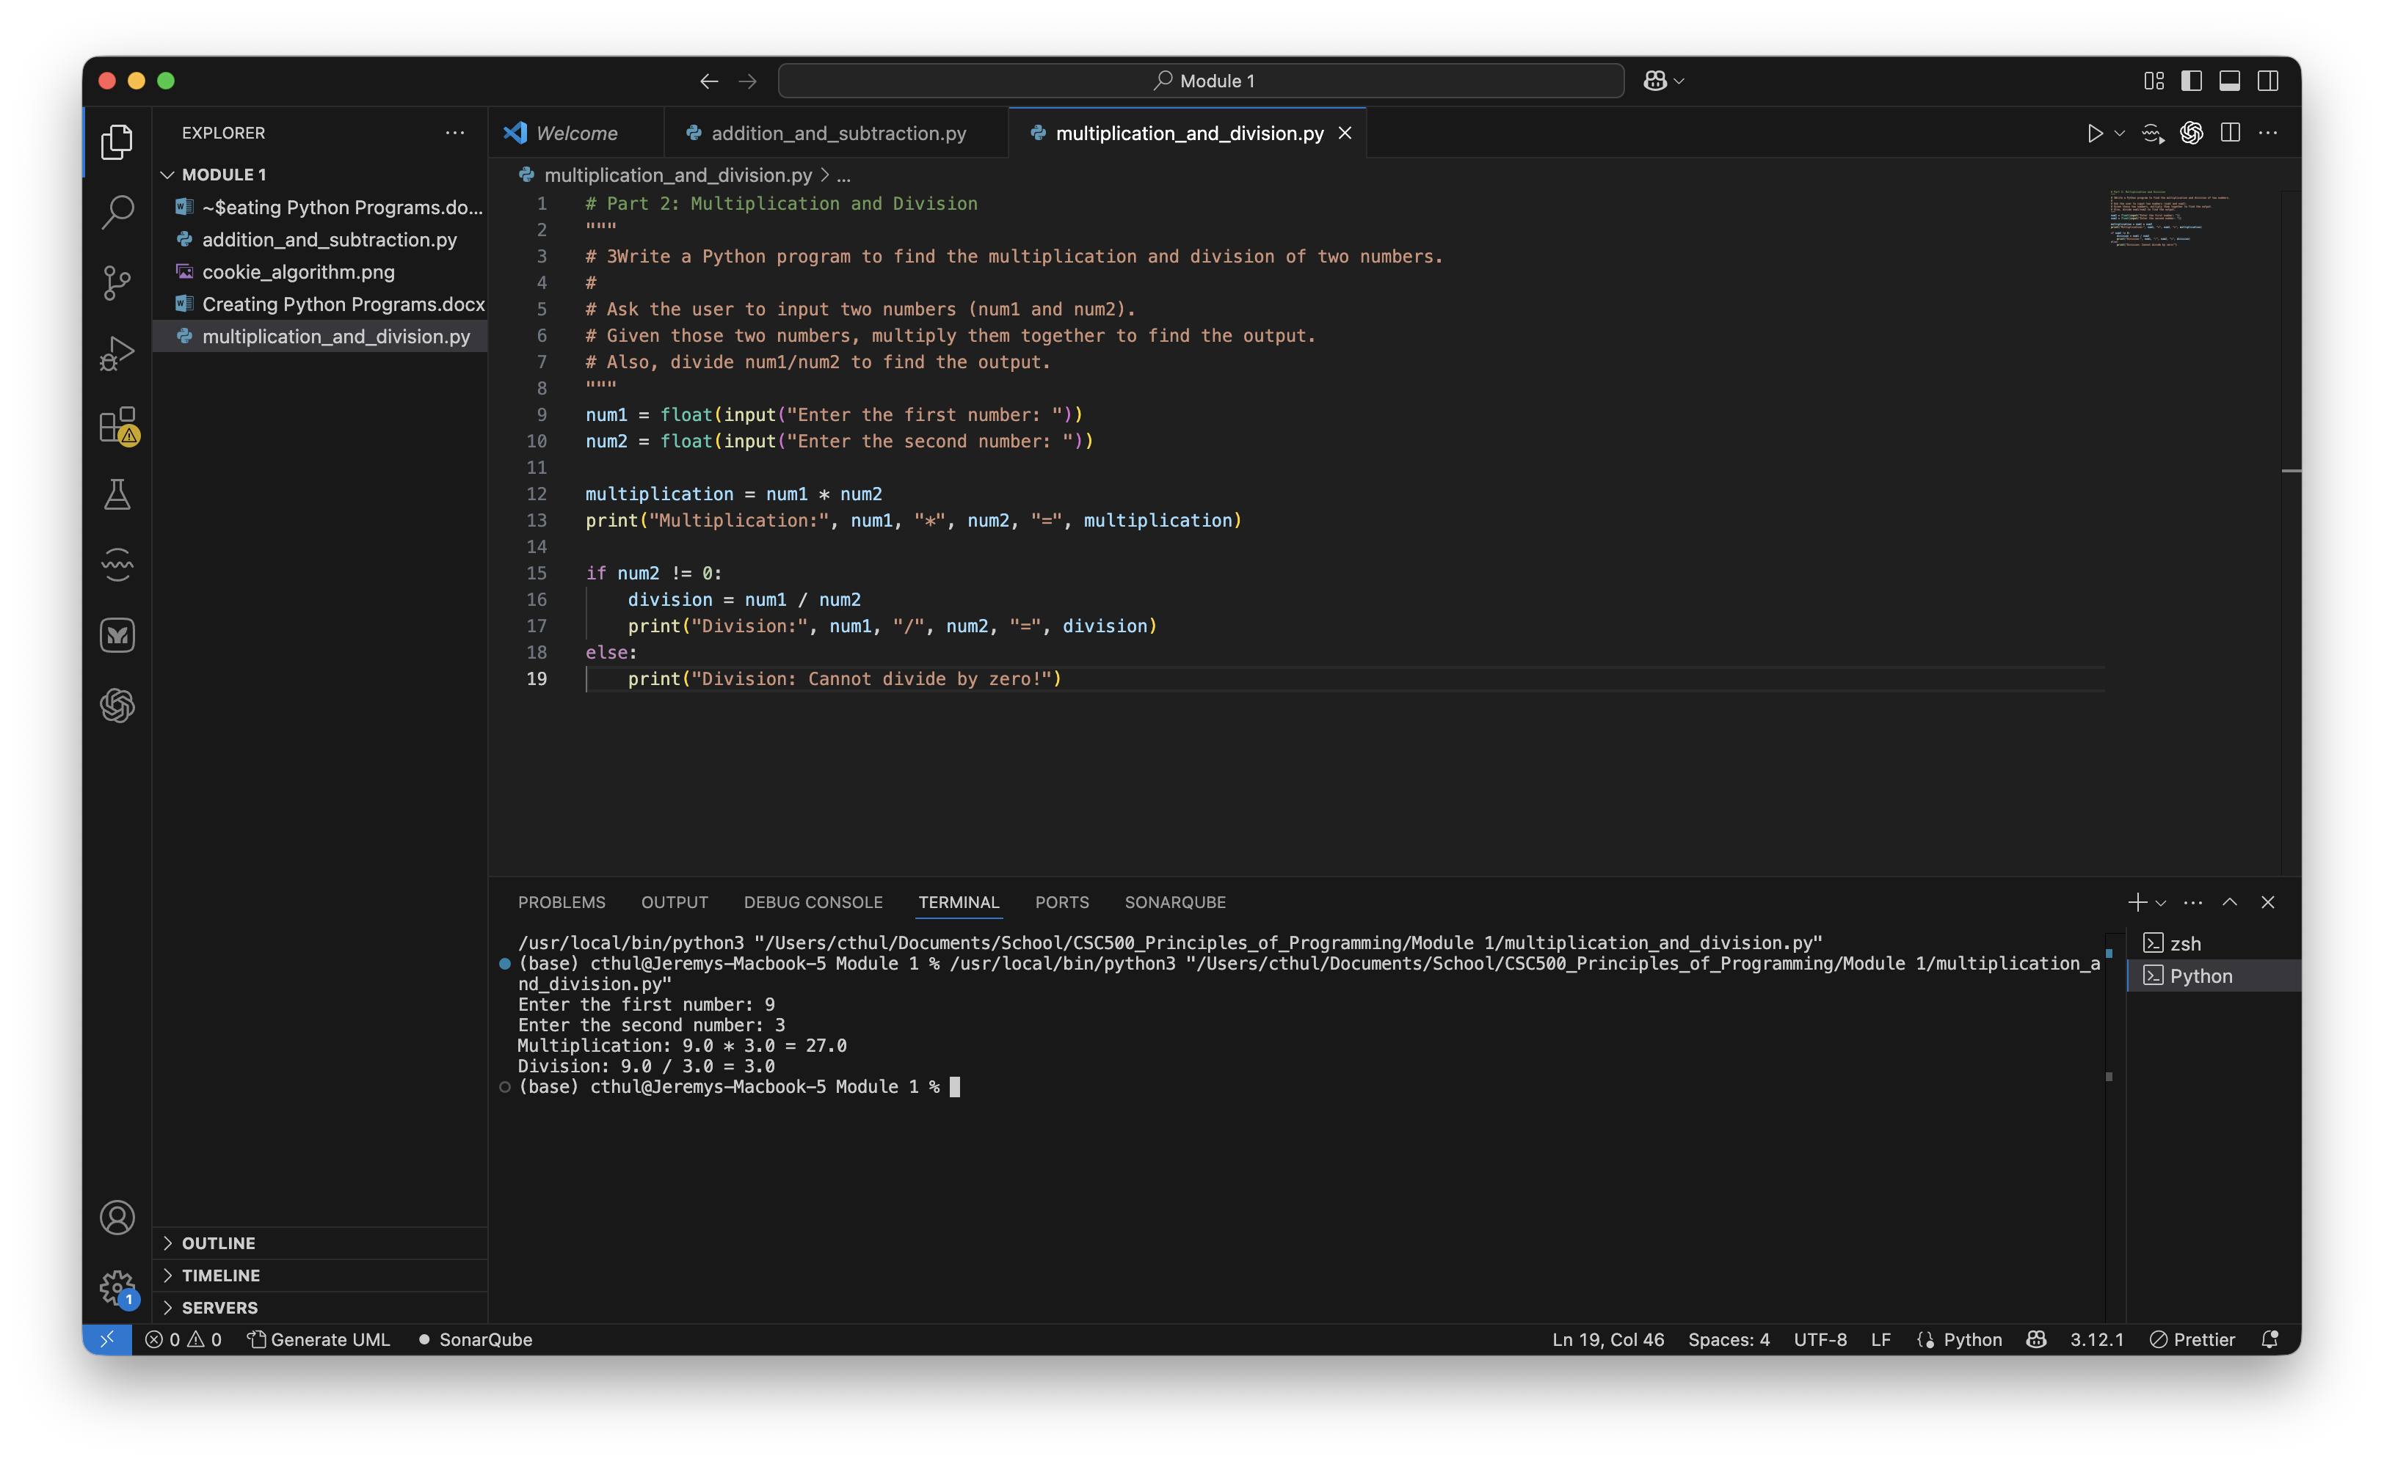
Results
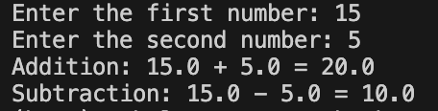
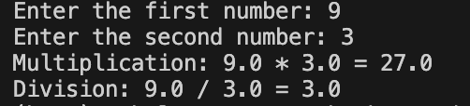
Github Repository
https://github.com/m9dful1/CSC500_Principles_of_Programming/tree/main/Module%201

